Der Riese — Zombies
Category: Rev | Difficulty: Hard

Description
A complete, playable first-person *Call of Duty: Zombies*–style survival game on a faithful recreation of the Der Riese layout, written from scratch in plain JavaScript (raw WebGL + Canvas2D + WebAudio) — no build tools, no dependencies, no network calls.
The mainframe will reward you at round 100. But the flag key is derived from a hash chain that is advanced only by the real round-advance code path, so you can't just set round = 100 — a naive jump produces garbage and the mainframe rejects it. Survive to round 100… or make the game think you did, legitimately.
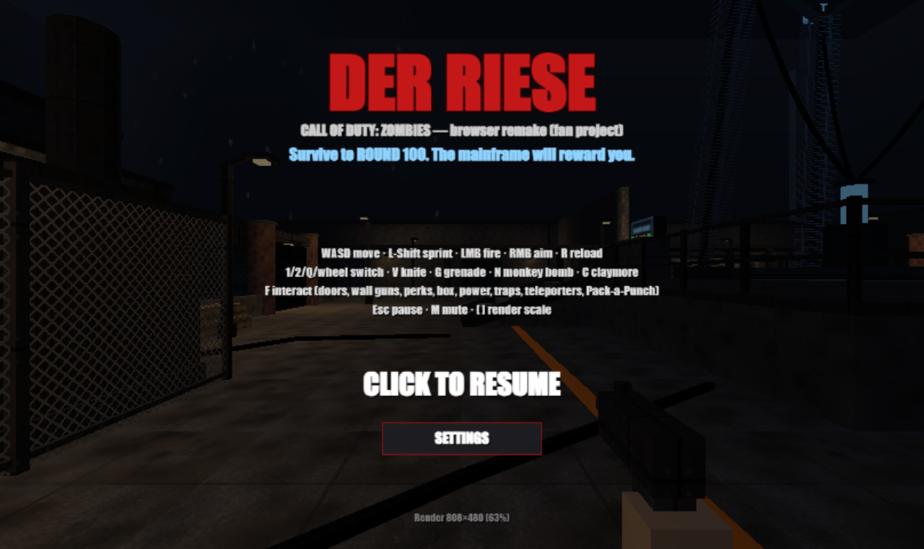
The Der Riese main menu

Files
Players get the deployable bundle in challenge/ — two static files (game.js + index.html), served by any static web server:
python3 -m http.server -d challenge 8000 # then open http://localhost:8000
The game needs only a browser; it works over plain HTTP anywhere. Organizer material is in organizer/: the dev page index.html (loads the individual js/ sources and exposes window.ZMDEV for testing; not shipped to players), the un-bundled sources in organizer/js/ (notably organizer/js/05_vault.js, the flag vault), organizer/tools/ (gen_flag.py, build.py, solve.py), and the encrypted flag in organizer/flag_data.js.
The vault design (in organizer/js/05_vault.js):
state = sha256("DER_RIESE::MAINFRAME::115")
on every legitimate round advance r (r = 2..100): state = sha256(state + ":" + r)
key = sha256(state_at_round_100 + ":FLAG")
flag = ciphertext XOR sha256-keystream (accepted only if sha256(flag) == tag)

Hint(s)
- game.round = 100 doesn't work — the screen says *MAINFRAME REJECTS DATA*. What is the only function that moves the round forward, and what does it do besides change the number?
- The flag key comes from a SHA-256 chain that must be stepped once per round, 2→100. You don't have to *play* all 100 rounds — you just have to call the real round-advance that many times.
- Game.advanceRound() (in 90_game.js) is the only caller of vault.advance(). Drive it 99 times from round 1, or statically replay the chain yourself and decrypt ZM.FLAG.

Walkthrough
Two intended routes reach the same flag: an in-browser hack that walks the real chain, or a static recompute of the chain offline. Both are shown.
- Recon. Open the game and play a round. The flag is promised at round 100; the HUD tracks the round, points, and your weapon. In game.js, the vault (ZM.Vault) and Game.advanceRound() show that each round advance steps a SHA-256 chain, and game.round = 100 only changes a display number — it never walks the chain, so the vault won't verify.
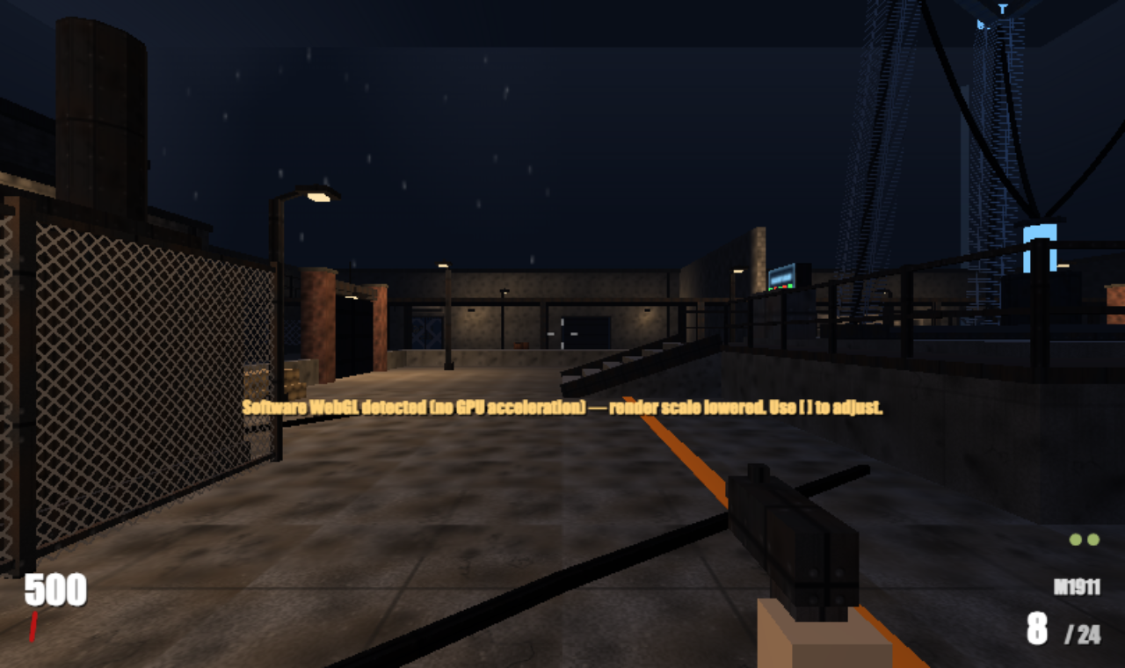
In-game: the Der Riese map, round in progress
- The bug / intended route A — in-browser. The round counter is cosmetic, but the chain state is real. Reach round 100 by calling the *genuine* round-advance repeatedly. On the dev build window.ZMDEV.game hands you the game object directly; against the shipped challenge/game.js (wrapped in an IIFE, no globals) you grab this from a breakpoint inside Game.update in DevTools → Sources, then run the loop in the Console:
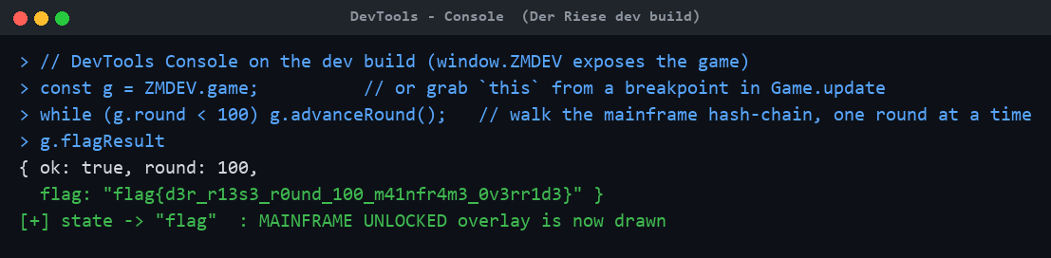
DevTools console: walk the chain to round 100
- Collect the flag. After the loop reaches round 100, unlockMainframe() opens the vault, the game state flips to the flag overlay, and the real flag is rendered on screen:
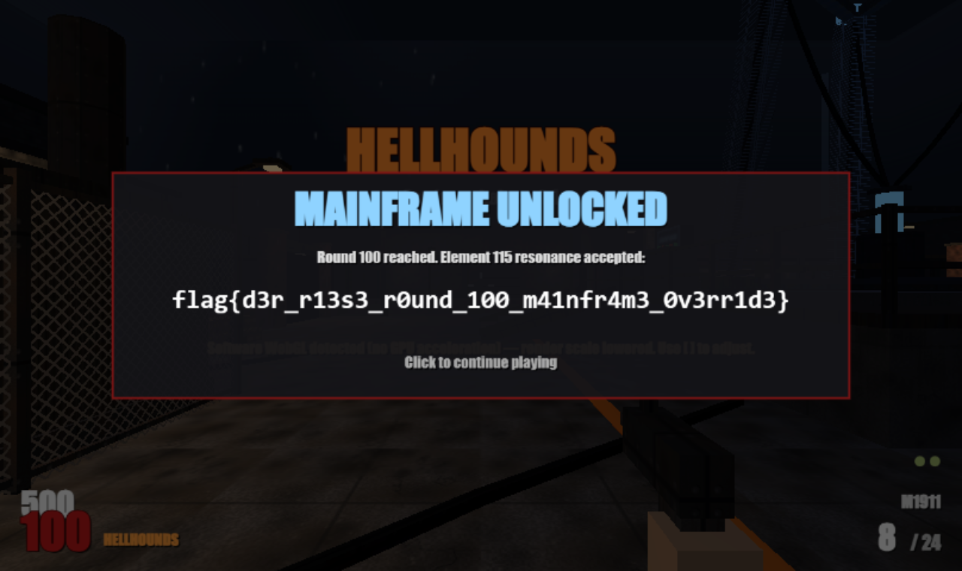
MAINFRAME UNLOCKED — the flag at round 100
- Intended route B — static recompute. You never have to touch the browser: the ciphertext and tag live in organizer/flag_data.js (and in the challenge/game.js bundle). Replay the SHA-256 round chain 2→100 exactly as the game does, derive the key, XOR-decrypt, and the integrity tag confirms the result. The reference solver does this with the standard library:
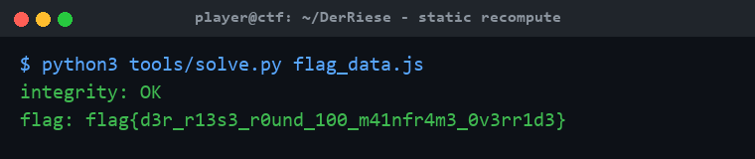
organizer/tools/solve.py recomputes the chain and decrypts the flag
Both routes yield the identical, integrity-checked flag.

Flag
flag{d3r_r13s3_r0und_100_m41nfr4m3_0v3rr1d3}

